SonarQube by KK FUNDA
=====================

Explain the flow diagram ----> Before maven and tomcat ----> SonarQube.

Def:
---

-> SonarQube is an open-source platform used for continuous inspection of code quality.

-> It performs static code analysis to identify bugs, vulnerabilities, and code smells in your code.

Key Features
=============

Code Quality and Security
-------------------------

Bugs and Vulnerabilities ---> Detect and fix issues that might lead to bugs or security vulnerabilities.

Code Smells --> Identify maintainability issues in your code.

Code Coverage --> Measure how much of your code is covered by tests.

Duplication --> Detect duplicate code blocks.

Technical Debt --> Estimate the effort required to fix all the issues in the code.

Multi-Language Support
----------------------

Supports a wide range of programming languages including Java, JavaScript, C#, C++, Python, PHP, and many more.

Quality Gates
-------------
Set thresholds for quality metrics to ensure code meets the standards before it is integrated into the main branch.

similar tools
--------------

SonarQube
Checkmarx
Coverity
Fortify Static Code Analyzer (SCA)
Veracode
PMD
ESLint
FindBugs/SpotBugs
StyleCop
Pylint
ReSharper
Flake8
Codacy
CodeClimate
DeepSource
Semmle LGTM
Klocwork
Infer
Bandit
Rubocop
Brakeman

what is the diff between code review and code coverage?
=========================================================

code coverage:
--------------

Number of lines tested through unit test cases called as code coverage.

In any project 80% need to satisfy.

Benefits: Helps identify untested areas of code

Tools: Tools like JaCoCo (for Java)

code review:
------------

Code review is the process of manually reviewing code by team members to find bugs, ensure to following coding standards, and improve overall code quality.

Benefits: It Leads to better software quality, fewer bugs, and promotes best practices within the development team.

Tools: Code review tools include GitHub Pull Requests.

SonarQube introduction
=======================

Type --> Continuous Code Quality
Vendor --> Sonar
Is it open source? --> for some programming languages.
Vesrion ---> 9.x
supporting OS --> cross platform
Is it executable software ---> No, download as a zip and extract it.

download link: https://www.sonarsource.com/products/sonarqube/downloads/

more information about SonarQube
---------------------------------

--> SonarQube previously called as a Sonar , It is open source software quality management tool.
--> It will continuosly analyze and measures quality of a source code.
--> In case any issues found, It will generate in html format/ PDF format reports.
--> It supports multiple languages like JAVA, c#, Java Script etc [Initially It was developed for JAVA]
--> It is supporting OS like mac,Linux, windows , etc
--> It will support multiple DBs like MYSQL, Oracle, PostgreSQL, etc
--> It will supports multile browsers like chrome, safari, IE, Microsoft edge, etc
--> It will identify the bwlow issues:
1. Duplicate code
2. Coding standards
3. unit test cases
4. complex code
5. comments
6. potential bugs [ Exception handlings]
.........

NOTE: with the help of SonarQube report we can stop the deployment also.

prerequsites for SonarQube Installation
=======================================

To install SonarQube, certain prerequisites must be met in terms of software and hardware requirements.

Below are the detailed prerequisites for installing SonarQube:

1. Hardware Requirements
------------------------
CPU: Modern multi-core processor.

RAM: At least 2GB of RAM (4GB recommended for production). go for t2.medium

Disk Space: 1GB of free disk space for the SonarQube installation, plus additional space for the database.

2. Software Requirements
------------------------
Operating System
-----------------
Linux (preferred)
Windows
macOS

Java
----
Java JDK 11 or 17
SonarQube requires the Java JDK (not just the JRE).
Set the JAVA_HOME environment variable to point to your JDK installation.

DB
--
Oracle
MYSQL --> Removed
MS SQL SERVER
POSTGRE SQL

DB is optional, Because of H2 is inbuild DB for SonarQube.

SonarQube installation
======================

step 1: launch t2.medium machine [4GB]

step 2: connect to that server

step 3: switch to root user [ sudo su - ]

step 4: install java

sudo yum install java-11-openjdk-devel -y

javac --version

step 5: go to /opt dir

cd /opt

step 6: yum install wget unzip -y

step 7: wget https://binaries.sonarsource.com/Distribution/sonarqube/sonarqube-9.6.1.59531.zip

step 7.1 : unzip sonarqube-9.6.1.59531.zip

step 8: mv sonarqube-9.6.1.59531 sonarqube

step 9: *************
As a good security practice, SonarQuber Server is not advised to run sonar service as a root user, so create a new user called sonar user and grant sudo access to manage nexus services as follows.

useradd sonar

step 10:

Give the sudo access to sonar user

visudo

sonar ALL=(ALL) NOPASSWD: ALL

step 11:

Change the owner and group permissions to /opt/sonarqube/ directory.

chown -R sonar:sonar /opt/sonarqube/
chmod -R 775 /opt/sonarqube/
su - sonar
cd /opt/sonarqube/bin/linux-x86-64/

sh sonar.sh start
sh sonar.sh status
sh sonar.sh stop
sh sonar.sh restart

step 12: Now you can try to access the SonarQube Server.

NOTE: default port number for Sonarqubr server: 9000

http://15.207.110.48:9000

NOTE: pls make sure to alolw traffic for 9000 port.

step 13: refresh the page

default credentials: uname: admin pwd: admin

stpe 14: It will ask to change the password

================================================================================================

Trouble shooting
=================
1. sonar user
2. traffic enabled or not
3. Java installed or not.
4. min 4GB RAM machine
------------------------------------------------------------------------------------------------------------------------------------------------------------------------------------------------------------------------------------------------------------------------------------------------------------------------------------------------------------------------------------------------------------------------------------------------------------------------------------------------------------------------------------------------------------------------------------------------------------------------------------------------------------------------------------------------------------------
Check the class from 47:00
In sonarcube we have sonarscanner
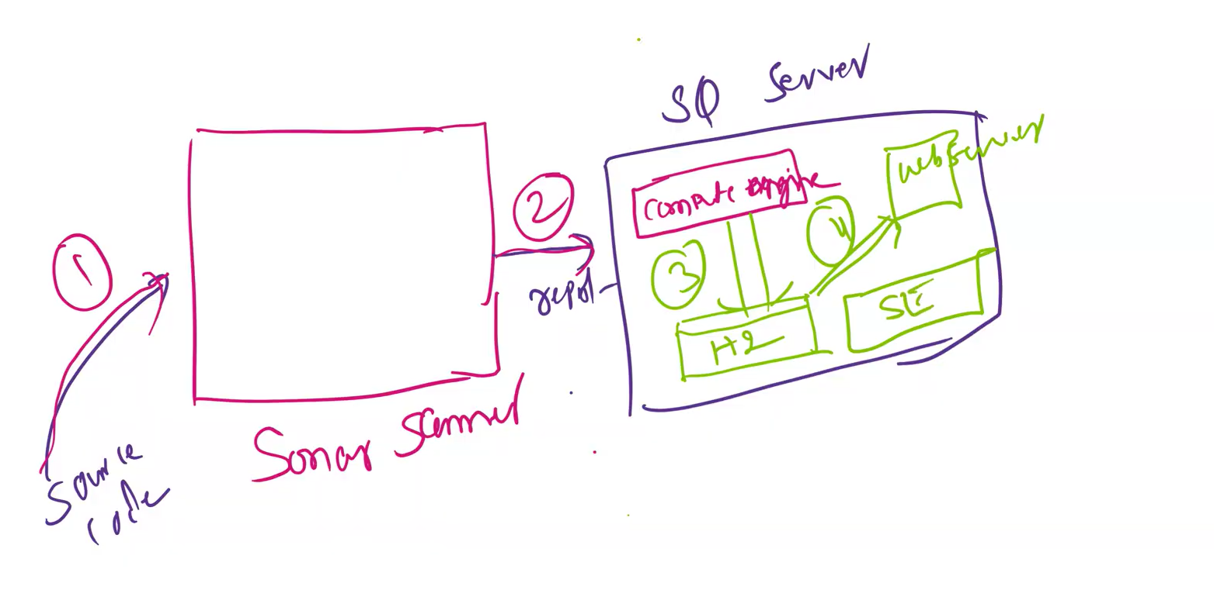
In the above image we have multiple items mentioned
1) source code
2) sonar scanner
3) Report
4) Sonarcube server
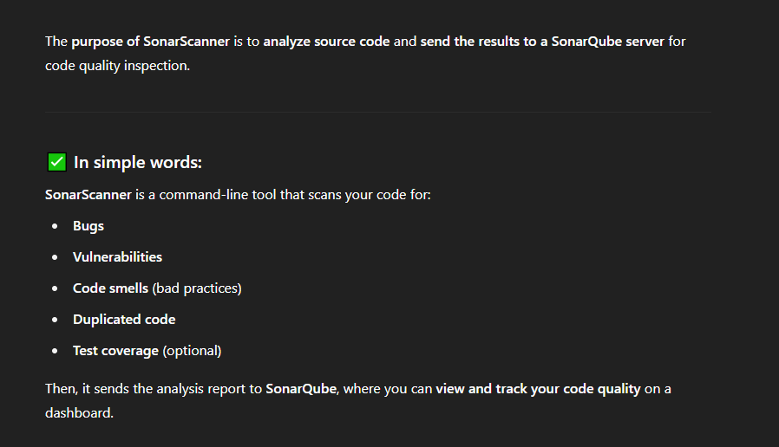
The H2 database in SonarQube is a built-in, temporary database that stores SonarQube’s data (like code analysis results, users, settings) when you're just trying out or testing SonarQube.
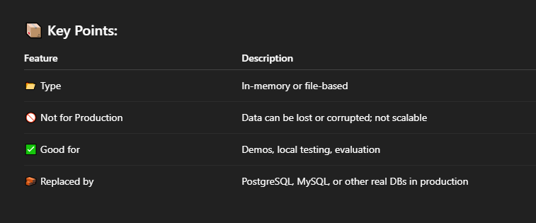
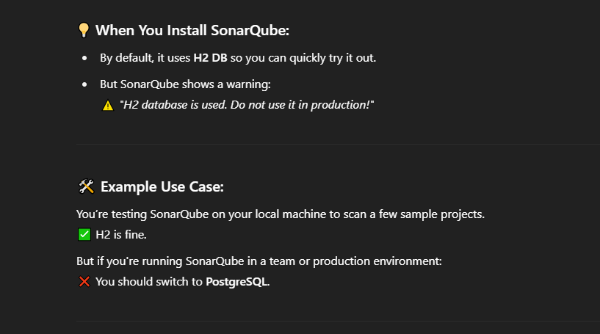
We can view the generated report result via Graphical userInterface using sonarcube web server
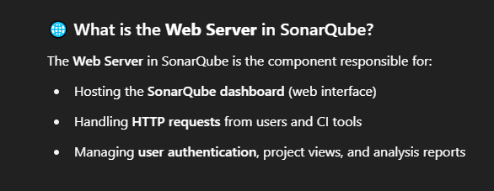
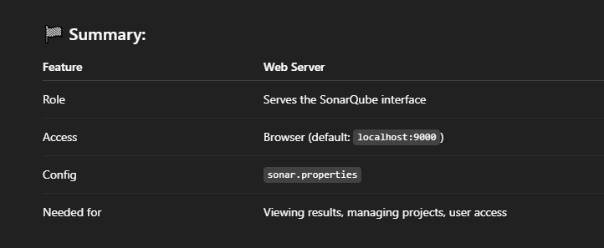
Let’s start installing the Sonarcube server in our ec2 instance In the Tutorial the Trainer has installed the sonarcube server in a new ec2 server called SQ-B4 you can ec2 instance setup video from (55:00)
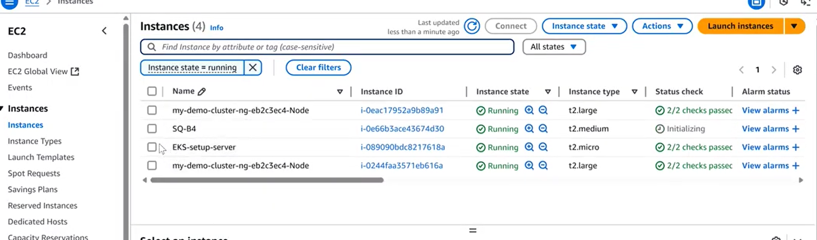
open the SQ-B4 instance in git bash and install the Sonarcube server in the SQ-B4 instance
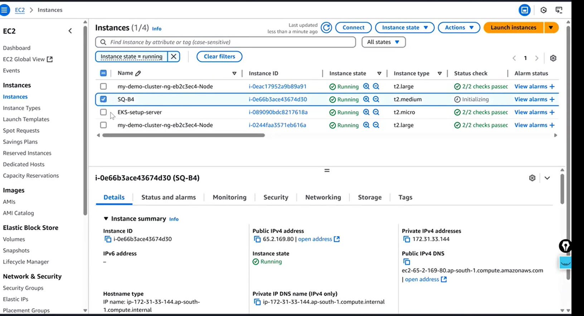
connect via SSH key
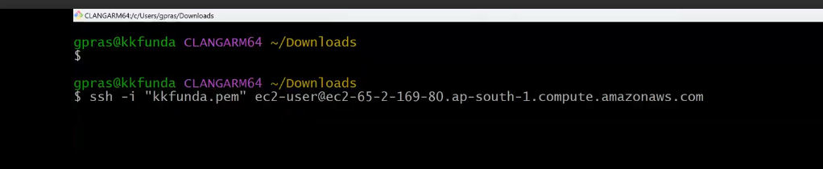
Download the community Edition via
wget https://binaries.sonarsource.com/Distribution/sonarqube/sonarqube-9.6.1.59531.zip
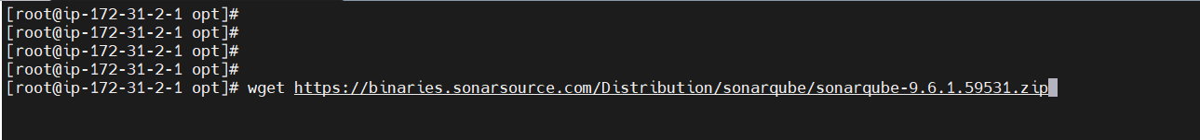
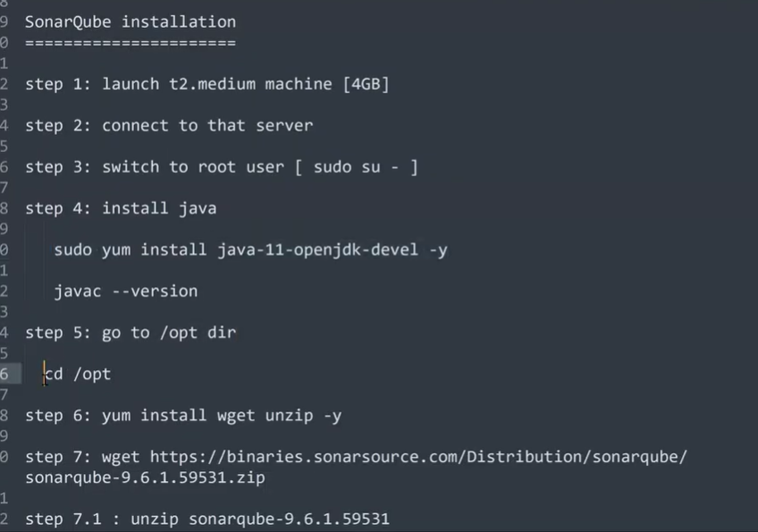
try to install java 11 version we have java 1.8 in our ec2 instance
download the sonarcube zip file in the /opt directory as you know all the external softwares are downloaded in the root’ opt directory

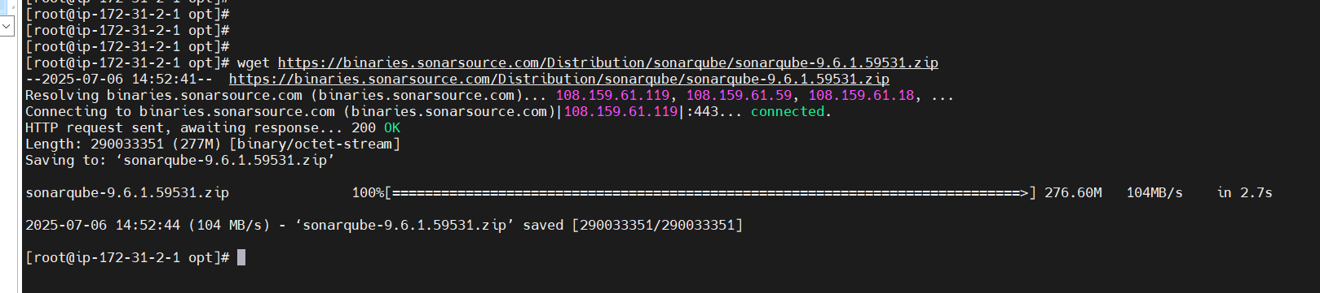
downloaded
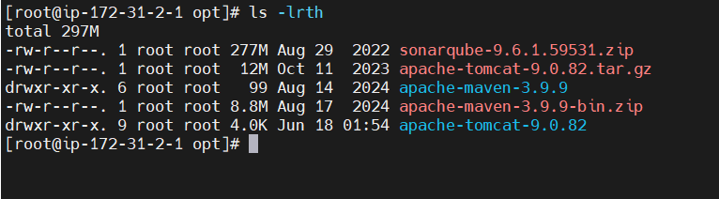
lets unzip it
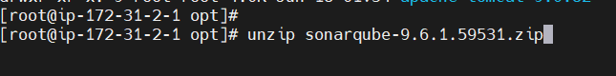
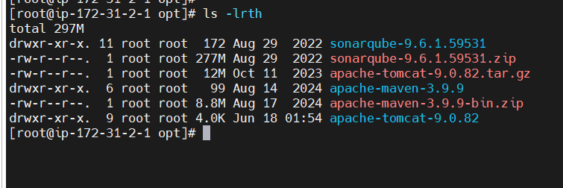
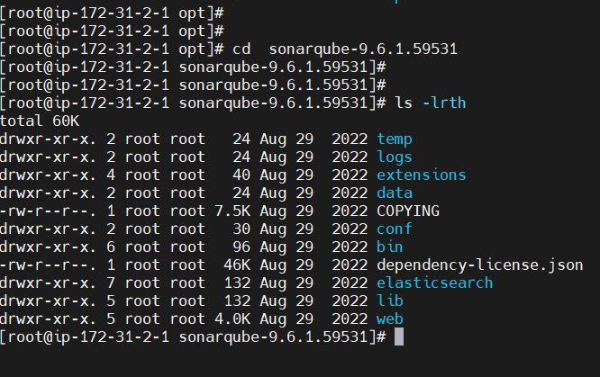
In the below image you can see that Trainer has renamed the sonarqube-9.6.1.59531 to sonarqube by using mv command as whon in the below image Lets do it in our ec2 instance also
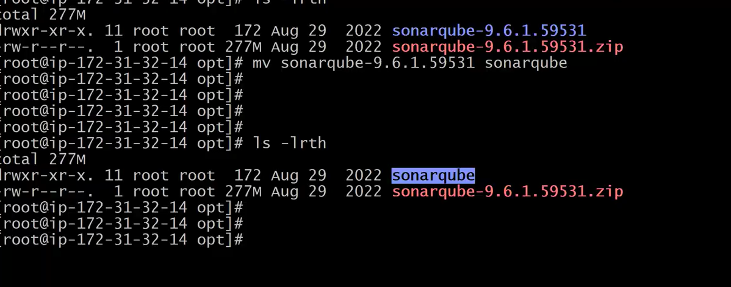
Rename the software name
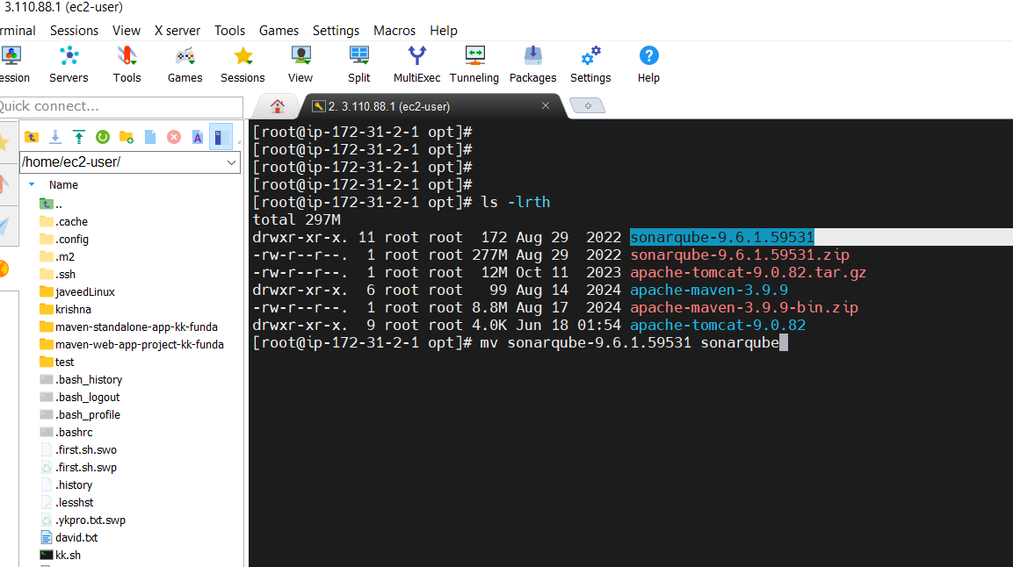
In the below image you can see we have change the software name from sonarqube-9.6.1.59531 to sonarqube
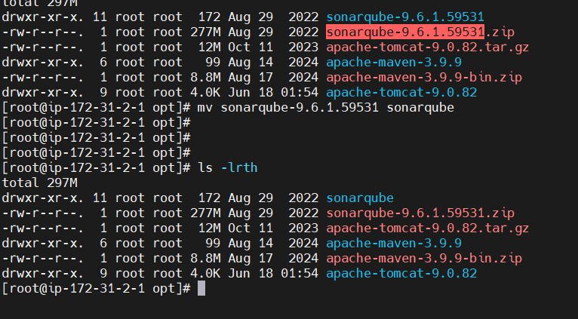
In the below notes image the 9th point is very point it is related to sonarqube bug we have to be very careful while implementing it
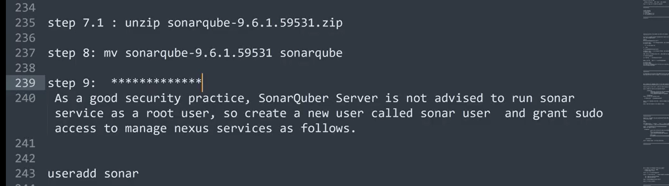
it means that we should not start the sonarqube server with root user instead we should create a user and through that user we have to sudo access to start the sonarqube server
Let create a user by using the below command
useradd sonar
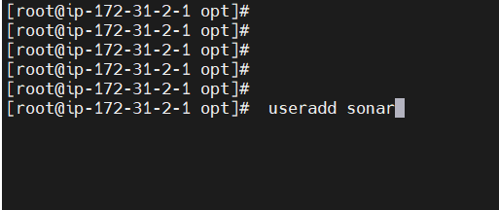
As you can see in the below Image the sonar user has been created
but to give the sudo access to any user we have edit the visudo file and add the sudo access to the sonar user
If we want to give the sudo access to any user we have to edit the visudo file as shown in the below image
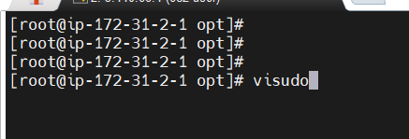
Add the sonar user after root
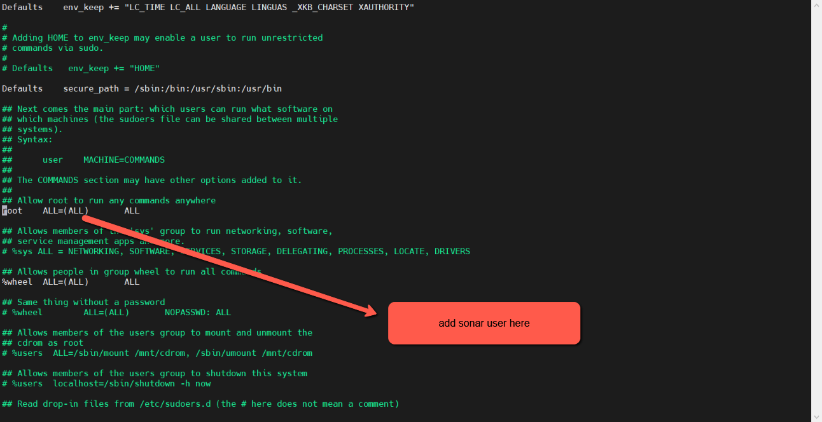
Added the sudo access to sonar user as shown in the below image
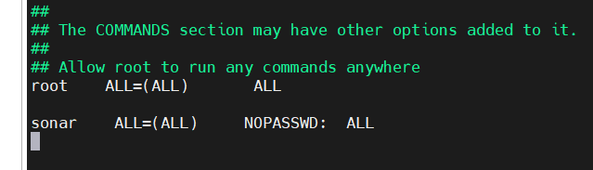
Next change the user and group of sonarqube directory from root root to sonar sonar by executing the following command 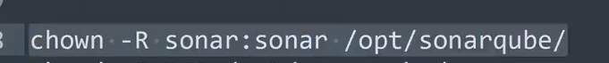
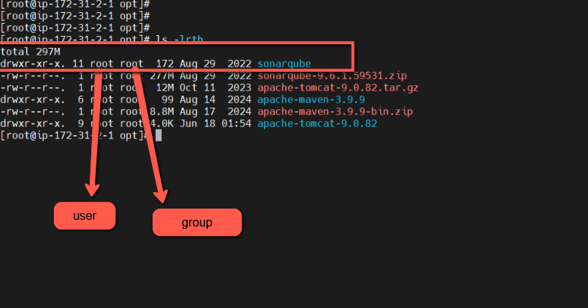
chown -R sonar:sonar /opt/sonarqube/
As you can see in the below image the user & group name for sonarqube has been changed to sonar sonar user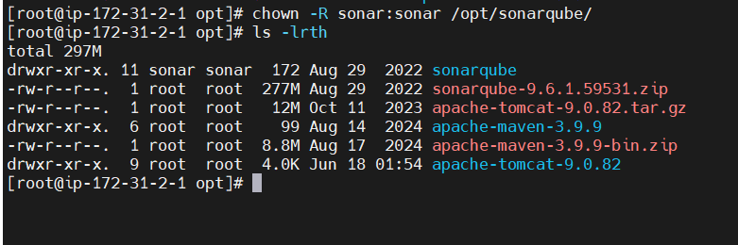
execute the below command to change the permission
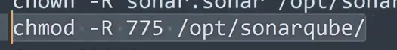
chmod -R 775 /opt/sonarqube/
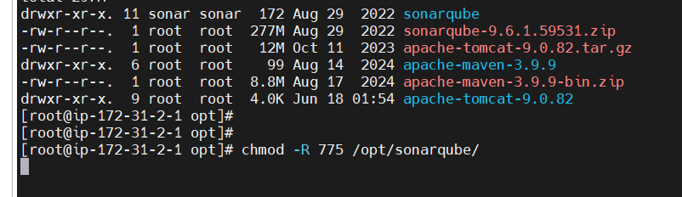
Now switch to sonar user from root to sonar user by executing su - sonar command
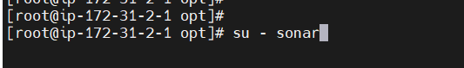
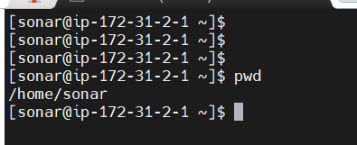
To run the sonarqube we have to run sonar.sh script which is present in the sonarqube server as shown in the below image
Navigate to sonar.sh file and run it
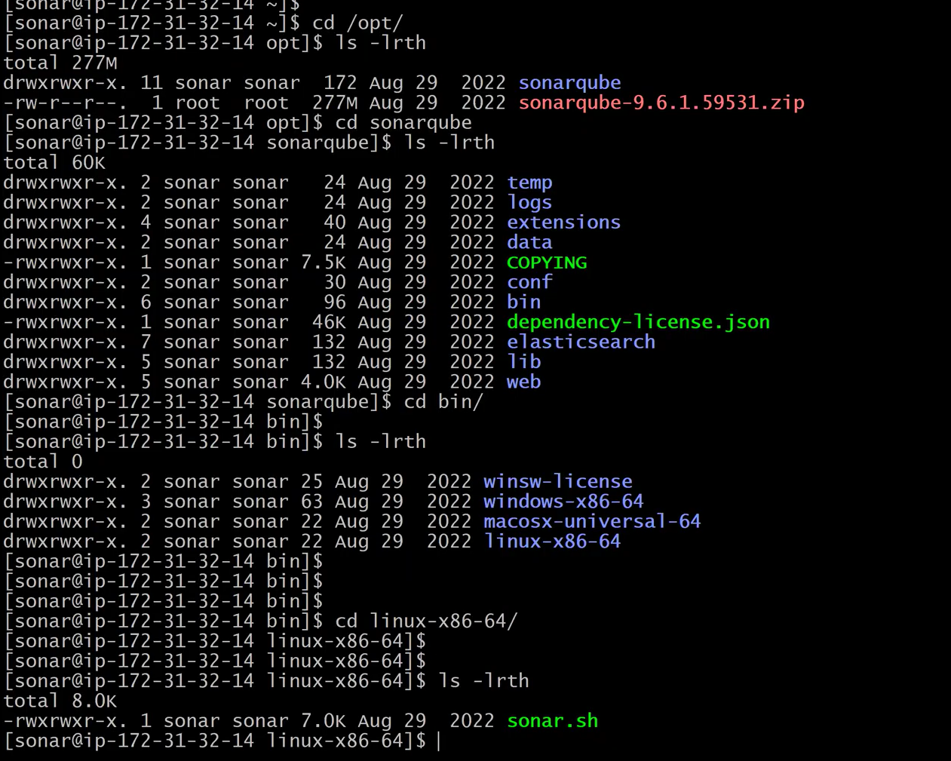
below is the address to Navigate directly to the sonar.sh file
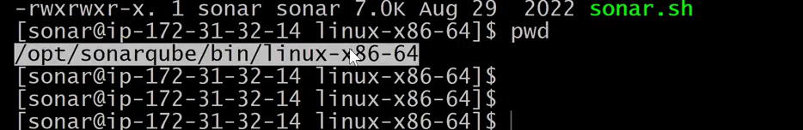
cd /opt/sonarqube/bin/linux-x86-64
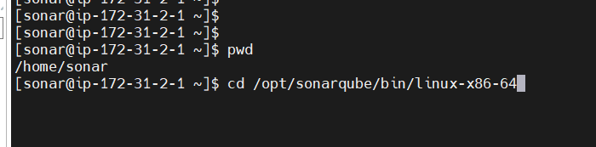
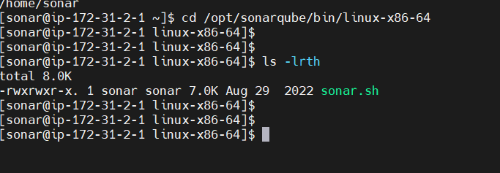
execute the command sh sonar.sh status to check the status of the sonarqube server
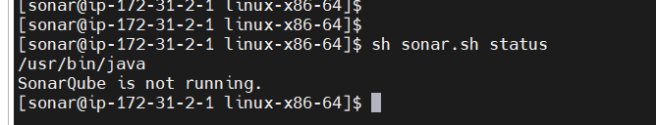
As you can see in the above image SonarQube is not running
To start the server we have to execute the command sh sonar.sh start the but we are getting error you can see in the below image sonarqube server is not running It is due java version issue
we have java version 1.8 but sonarqube server reuiqres java11 version so lets try to install java 11 version.
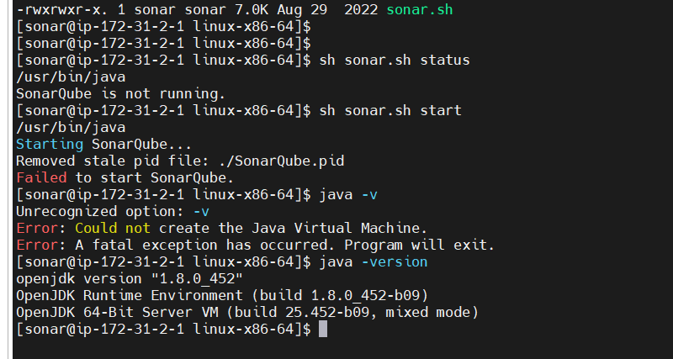
I have just installed java11 ( sudo yum install java-11-openjdk-devel –y )
but still getting the older java version (1.8.0) to overcome this issue we have to make configuration setting by executing the following command
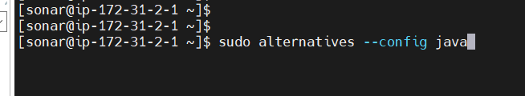
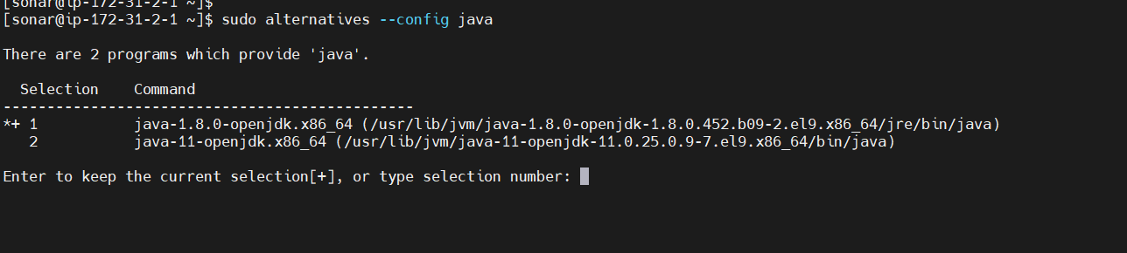
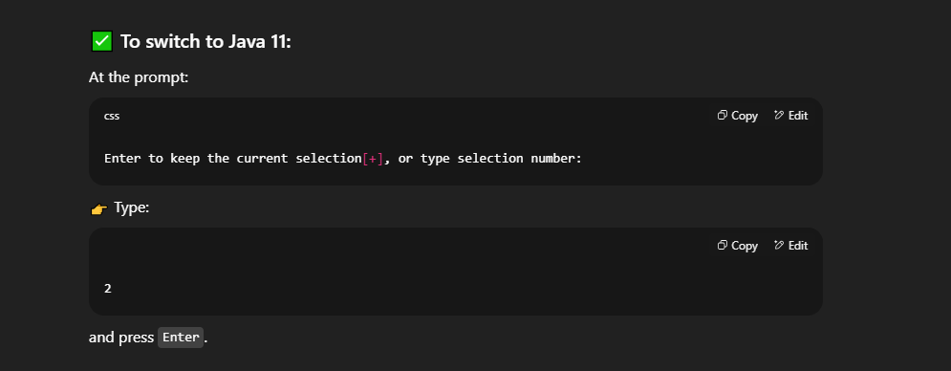
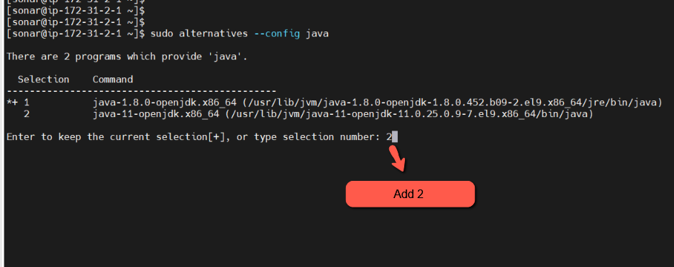
After adding 2 press Enter
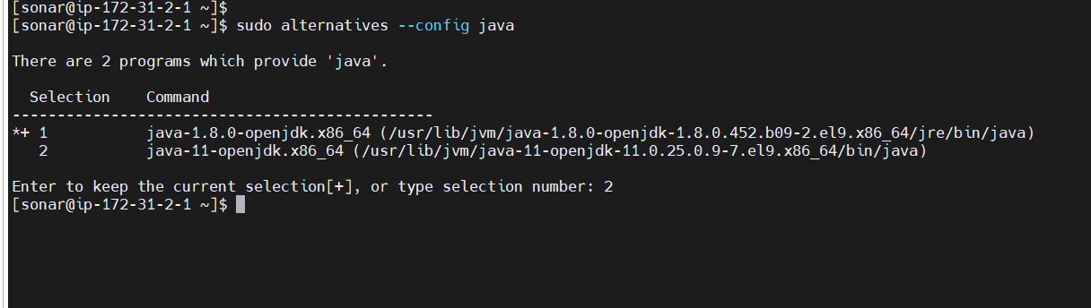
Now check the java version
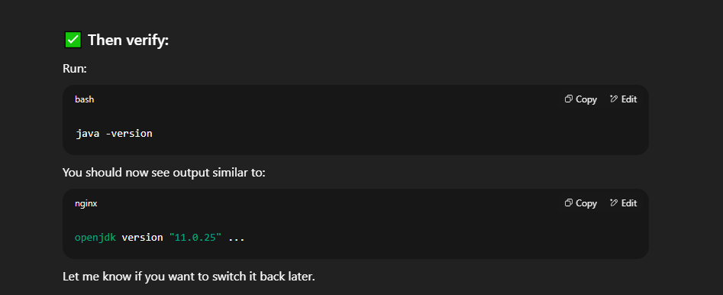
As you can see we switched to java 11
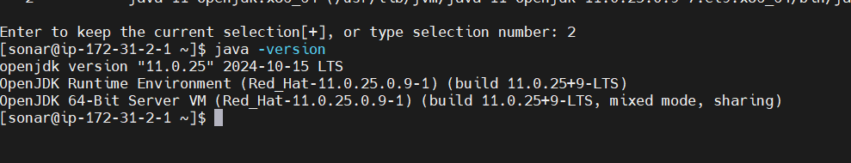
Now let go to the cd /opt/sonarqube/bin/linux-x86-64 and execute the command sh sonar.sh start
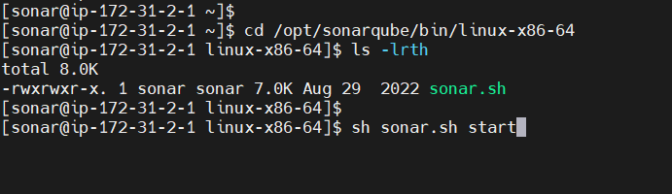
Wow!!!
As you can see in the below image the Sonarqube server has been started
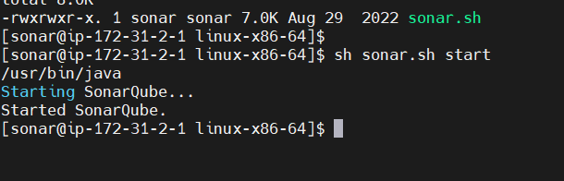
To access the sonarqube server on the web we have to use the port number 9000
execute the command ps -ef | grep -i "9000" to Displays information about running processes.
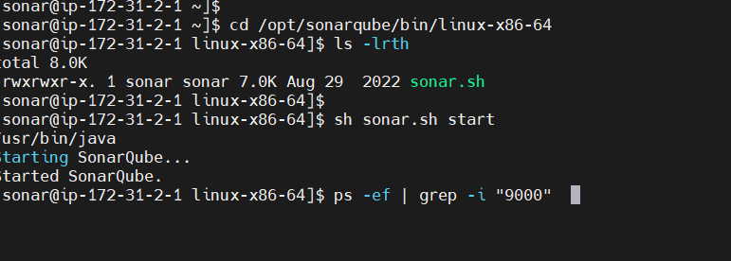
As you can see in the below image that the sonarqube server is running
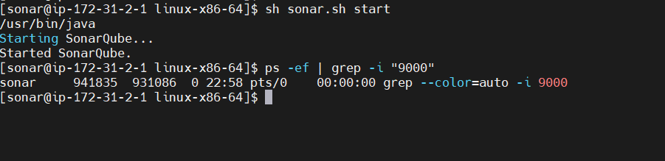
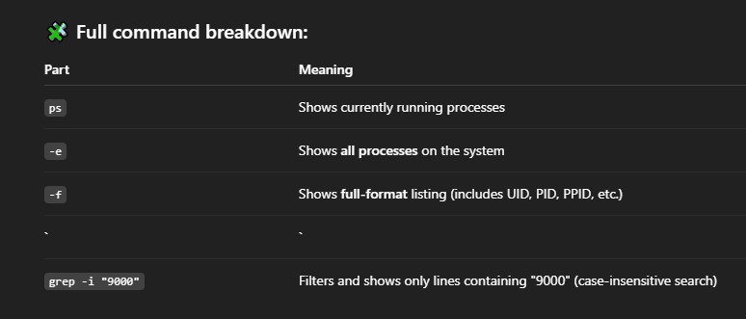
below image shows another way to check the sonarqube server is running or not
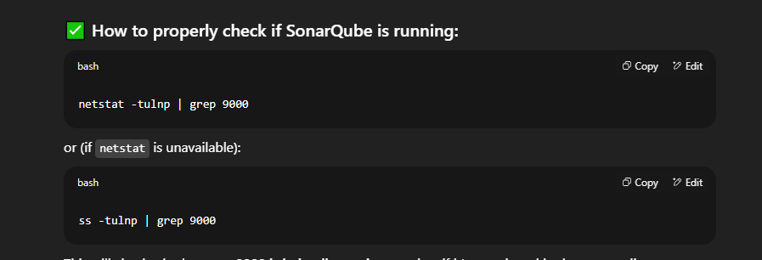
Now to access the sonarqube server on the web we to add cutom TCP 9000 in the security group of our ec2 instance
Then access the sonar qube server
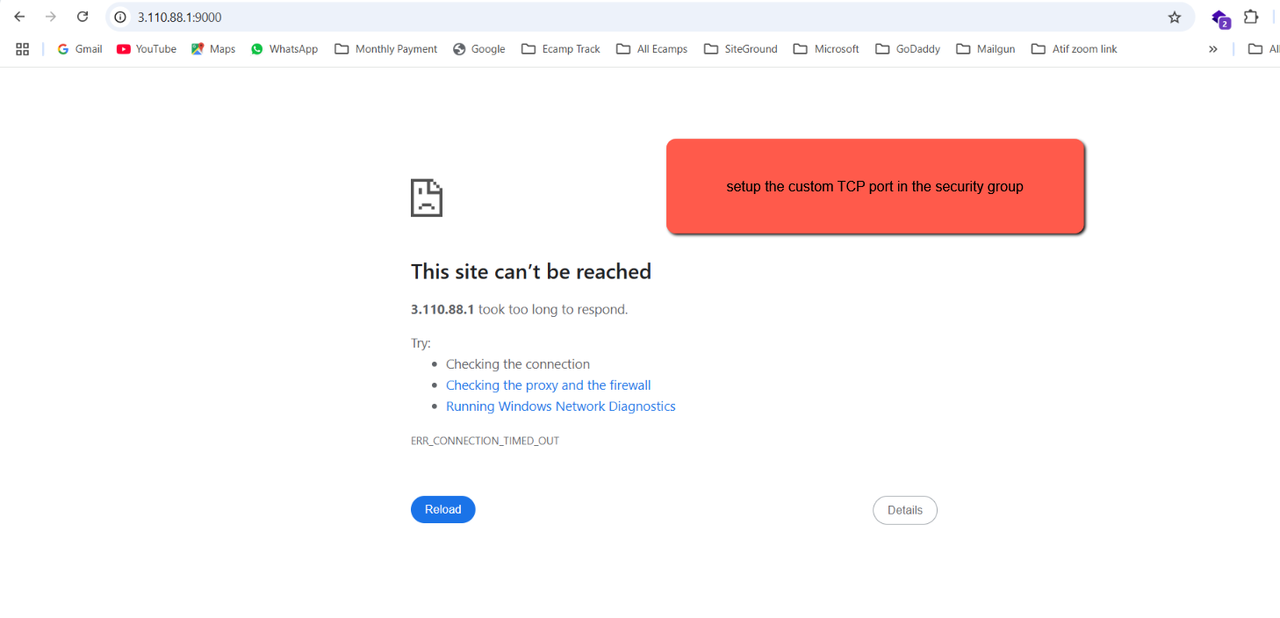
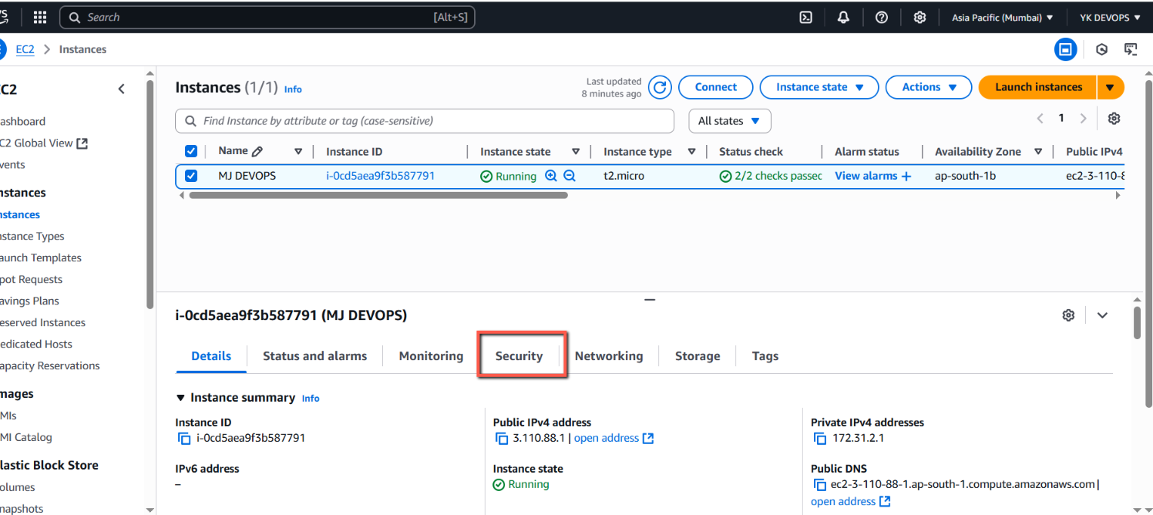
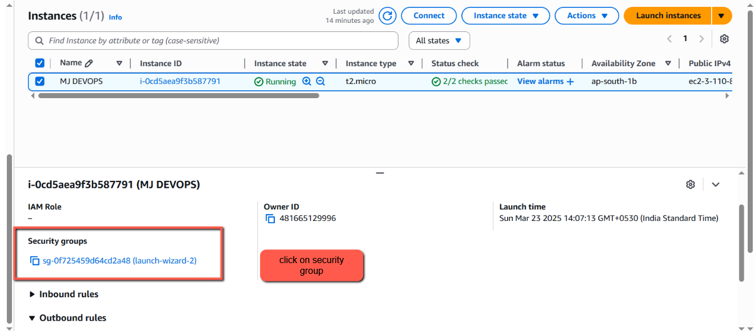
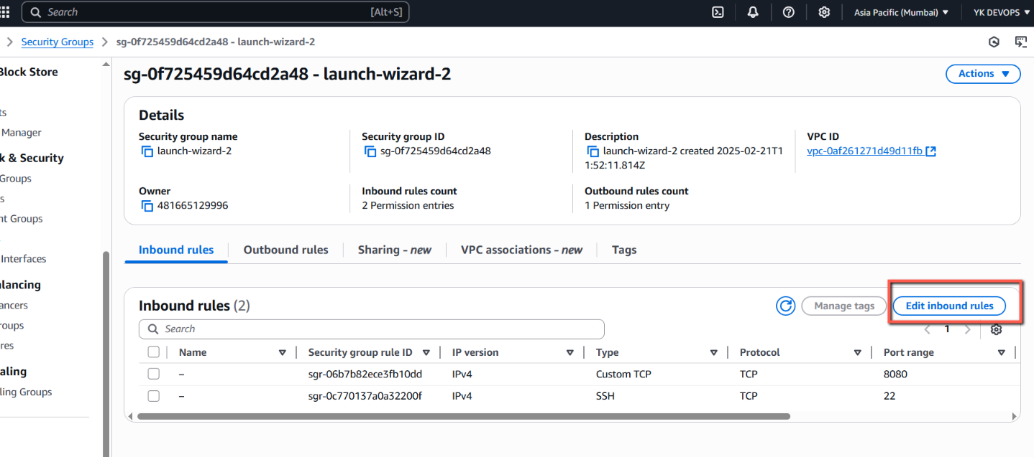
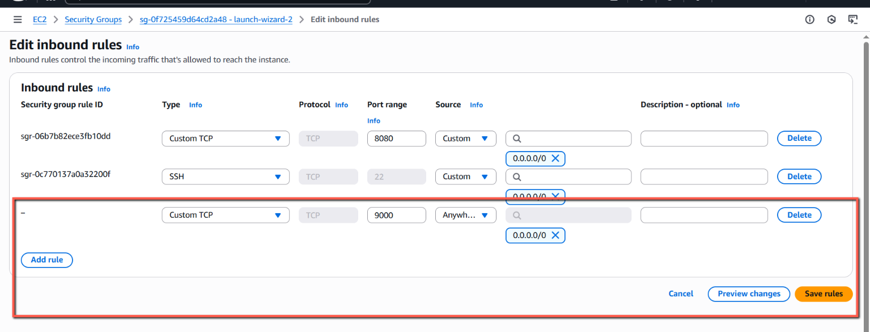
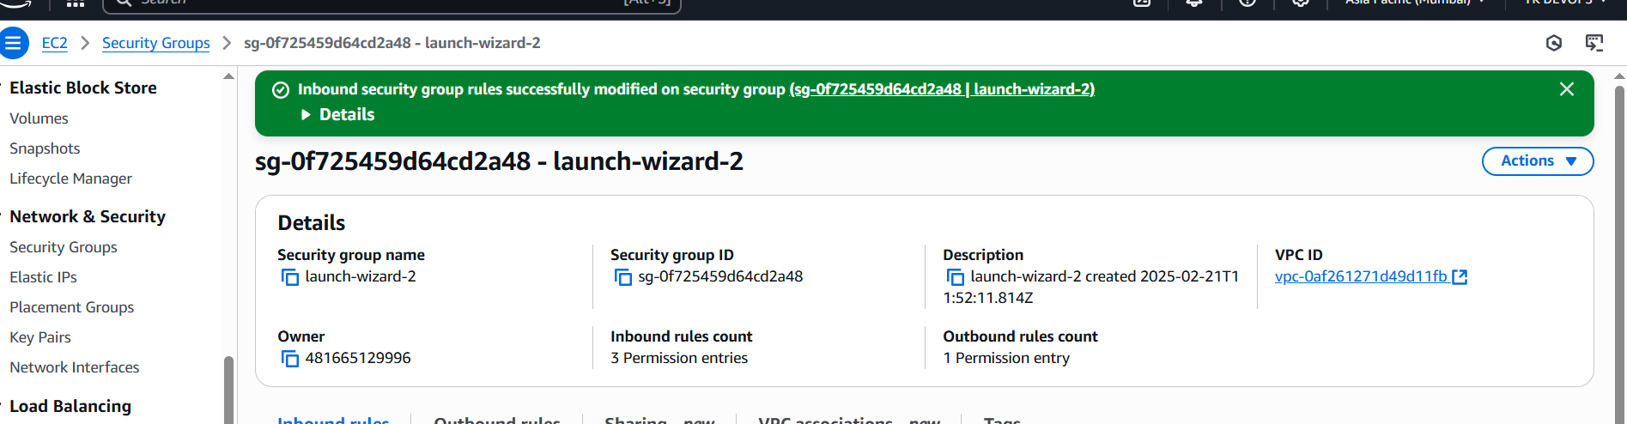
we found out that my sonarqube server is not running found out the solution through chatgpt
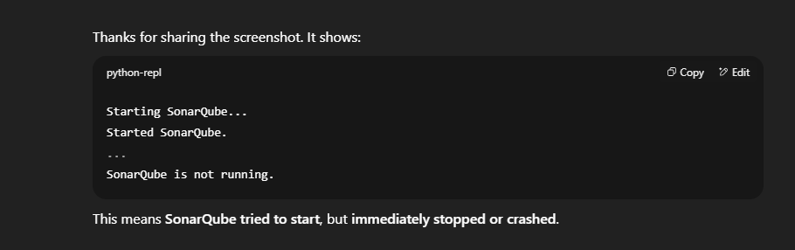
cat /opt/sonarqube/logs/sonar.log | tail -n 50
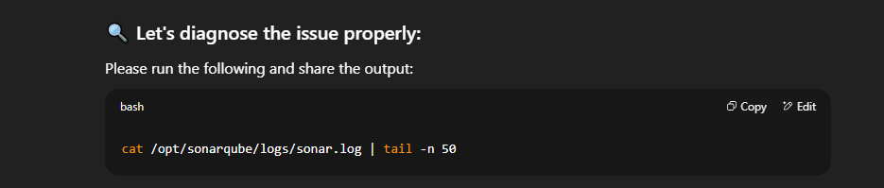
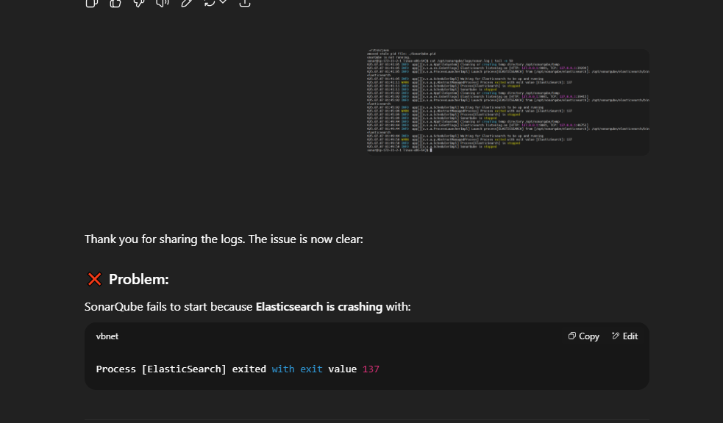
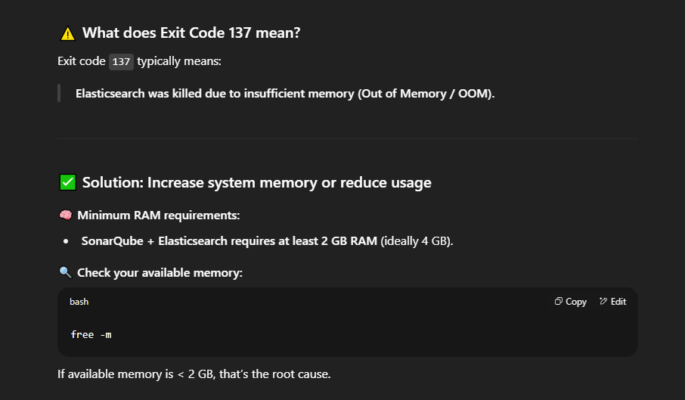
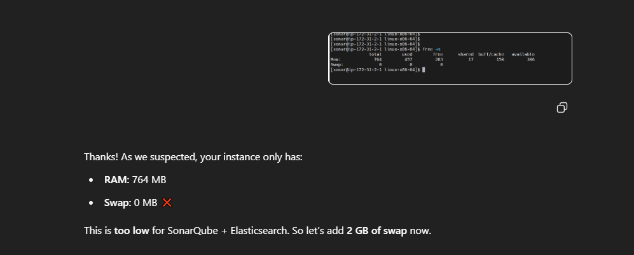
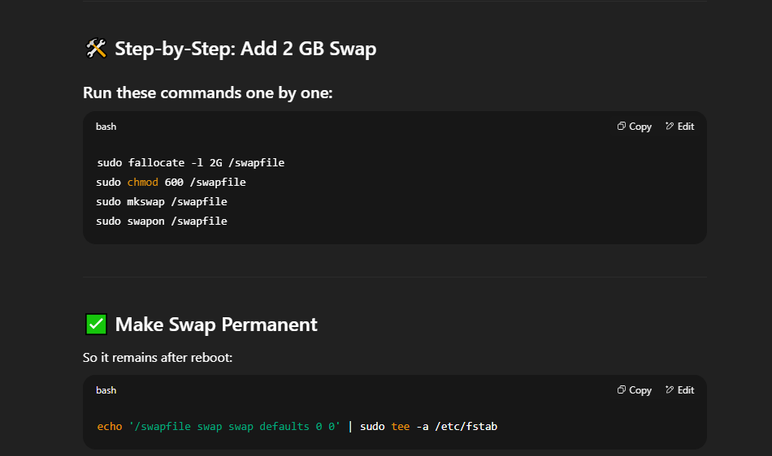
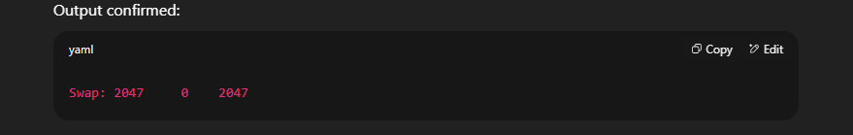
The issue has been resolved and finally able to access sonarqube server via web
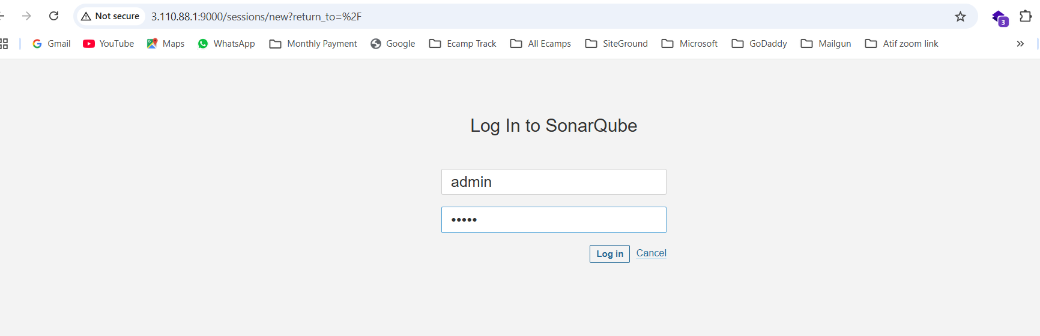
admin
admin
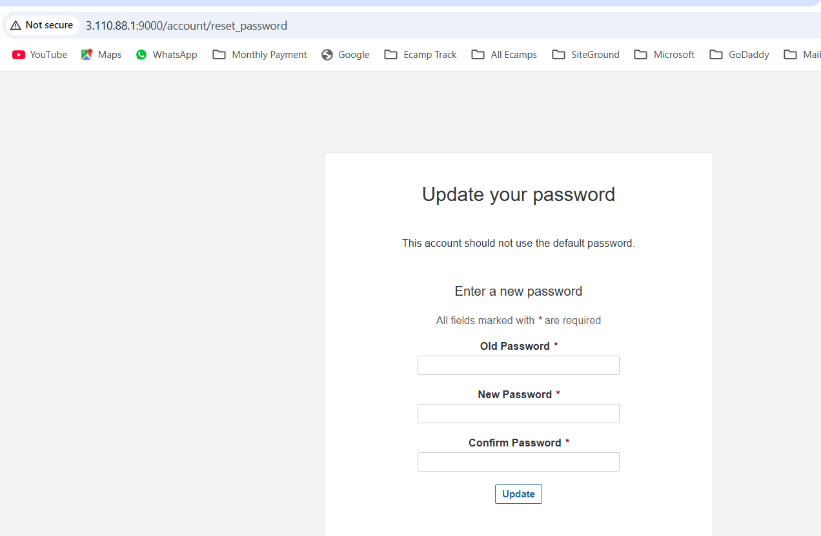
New password is : welcome123 username is : admin
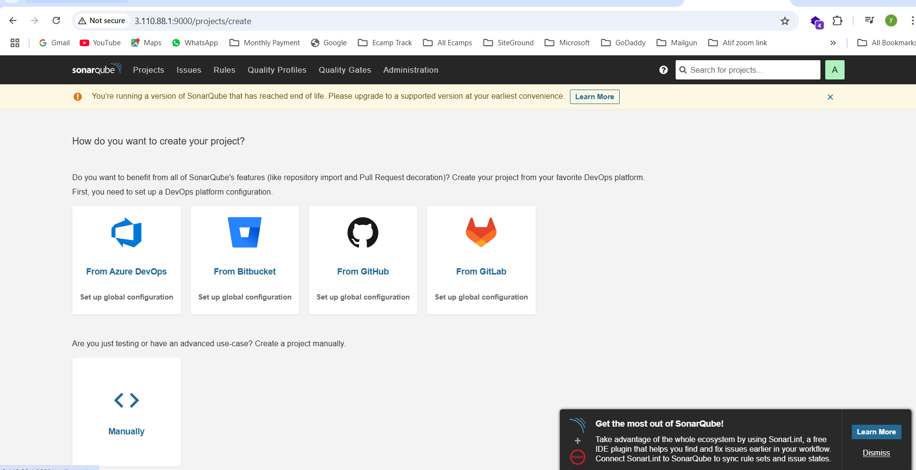
we will discuss about this sonarqube in the Next class

